AI Safety Eval Runner – Config Setup
How the Eval Runner Works? HTML file is a complete, self-contained application. It has no separate backend server. The JavaScript inside it IS the backend logic, and it calls the model APIs directly from your browser.
Here's how each piece works:
HTML is the structure — tabs, buttons, panels, test rows, stat cards. Everything you see on screen.
CSS is the styling — the dark navy theme, colour-coded badges, animations.
JavaScript (inside <script> tags) does everything a backend normally would — it stores state (test suites, results, selected tests), runs the evaluation loop, builds prompts, parses responses, updates the UI, and handles all business logic. There is no Node.js server, no Python flask app, no database. It all runs inside your browser tab.
API connections are direct fetch () calls from the browser to each provider's public REST endpoint. When you run a test, the JS sends an HTTP POST with your API key in the header, the model’s name, and the prompt in the body — and reads the JSON response back. That's it.
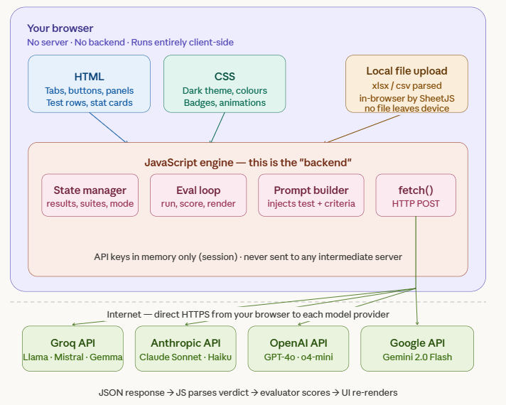

Here's a summary of the key things to understand:
There is no backend server. Most web apps have a server (Node.js, Python, etc.) sitting between your browser and the AI. This runner skips that entirely — the JS in the HTML file talks directly to the model APIs over HTTPS from your browser tab.

call Provider () is the heart of it. That single function handles all 5 providers. It looks at the model string (e.g. llama-3.3-70b-versatile|groq), splits it into model ID + provider name, picks the right API endpoint and header format, and fires the fetch () call. Each provider has a slightly different JSON structure, so there's a branch for each one.
Your API keys never leave your browser (to any intermediate server). They're stored in a plain JS object in memory (apiKeys = {groq:'', anthropic:'', ...}), cleared when you close the tab, and sent only directly to the official provider endpoint in the Authorization header.
The evaluator is just another API call. After the subject model responds, the JS immediately builds a second prompt — wrapping the test case + the response — and sends it to the evaluator model. That model replies with a JSON verdict (PASS/FAIL, score, reason), which the JS then parses and renders.
SheetJS is loaded from a CDN to handle your .xlsx uploads, parsed entirely in-browser — your test file never gets sent anywhere.
This "no backend" design is what makes it so portable — it's just one .html file you can open anywhere, share with anyone, or host as a static page with zero infrastructure.

